

FLIGHT FARE PREDICTION USING MACHINE LEARNING



# Wireframe documentation

ch yaswanth kumar

## november- december, 2021

iNeuron

* **Wire Frame Architecture**

The below is the landing page of single page Application that is responsible for Predicting the Flight Fare based on features selected. Below are some key points to be noted.

* The Application UI based on form fields based on selected features filtered from raw dataset like

Number of Stops, Journey Date and Month, Arrival ands Departure Time, Source and Destination,

Airline Details etc.

* The Predict button invokes the prediction function of corresponding model based on populated features list from the UI given as input.
* However, only single instance prediction can be done at a time in this application.
* All fields are mandatory to be filled before hitting the Predict button.
* Based on populated values it will predict the numerical value of estimated flight price.

Test Case

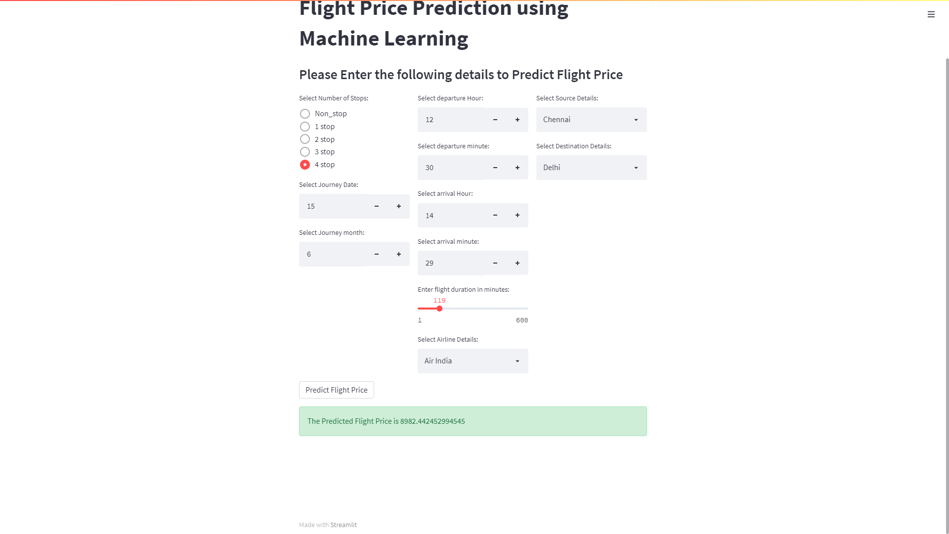

* The Web UI can be adjusted as both vertical and horizontal view via Streamlit settings in browser.

